# Water Concerns in a Changing World

## Sophie L. Masud

## MUMA College of Business, University of South Florida

## ISM 6419: Data Visualization

## Dr. Han Reichgelt

## April 29, 2023

# Water Concerns in a Changing World

In the past few years, more and more incidents tied to water issues have made the news. The rise of Boko Haram in Africa has been tied to Lake Chad’s drying up in the past few decades. The United States’ southwestern and western states are routinely suffering severe droughts, forcing some communities to rely on bottled waters as wells run dry and experiencing mega-fires which can take months to extinguish. This year, southern Europe has already begun implementing drought-restrictions in winter, months earlier than usual. In contrast, other areas, or the same areas at different times, have seen record-setting rain and snow falls, causing catastrophic floodings. With this in mind, two questions arose for me. The first, are there continents and/or countries experiencing high levels of water stress? The second, are there countries at higher risk of experiencing international conflicts due to their water dependency on their neighbors?

As one would expect, the topic of water in the time of climate change can become very broad very quickly. Keeping the research questions narrowly defined was crucial. Remaining focused on just answering these those questions was key to keep this assessment manageable.

I first focused on finding worldwide data across as many years as was available. My main source of data was the World Bank. I ended up being constrained by the availability of complete datasets on more detailed topics such as water stress levels. It became clear that the widest range was going to start in 2010 and end in 2019. I also removed countries that did not report data for all dates in that decade. These turned out to be mainly very small countries like Monaco or smaller island states such as Barbados, Sao Tome, etc. and did not affect the continent-level totals by much. I downloaded the Earth’s annual average temperatures from the Environment Protection Agency which sourced it from the National Oceanic and Atmospheric Administration. Additionally, the Food and Agriculture Organization of the United Nations provided a good source for the level of fresh water withdrawal per country over the same timeframe. Finally, some datasets had the countries listed by name, others by code. I downloaded the official list from the United Nations’ Statistics Division to help handle any discrepancy.

To answer the first question, I looked at renewable internal fresh water availability and withdrawals, across the five continents. The World Bank metadata defines the first metric as the total actual renewable water resources that correspond to the maximum theoretical yearly amount of water actually available at a given moment. The country-level data available from that group showed the same value from 2010 until 2019. I compared it to the quantity of fresh water withdrawn in 2010 and in 2019 to find potential patterns. Based on that metadata, it totals up the water usage by the various economic sectors and by individuals. At first sight, nothing stood out. Looking at the figure below, Asia, the largest and most populous continent, has 11,064 billion cubic meters of renewable water each year, largely covering its annual withdrawals of 2,166 billion cubic meters in 2010 and 2,235 in 2019. A similar pattern emerges for all the continents. What I learned in researching the topic is that when fresh water is concerned, the raw numbers look deceiving.

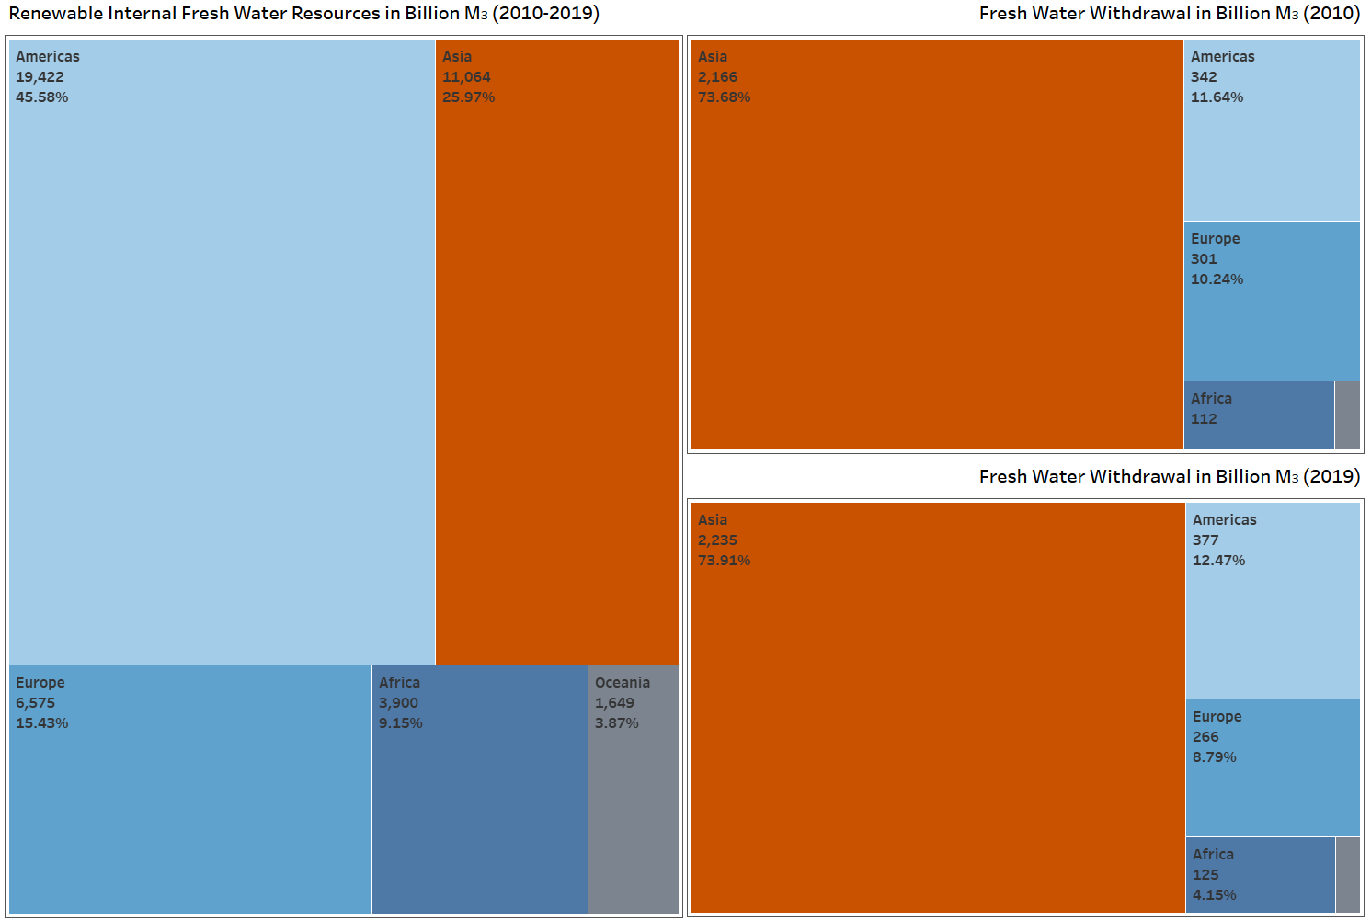

To look for actual signs of potential trouble, I turned my focus to the water stress data. The World Bank metadata defines it as “the ratio between total freshwater withdrawn by all major sectors and total renewable freshwater resources, after taking into account environmental water requirements.” One could think that a value below 100% for this ratio would be acceptable. After all, that would mean that a country uses up less than its renewable water each year and implies it would not run into issues. However, a country with a ratio above 80% is considered to be experiencing an extremely high level of water stress. Ideally, the ratio should be between 10 and 20% (World Resources Institute. 2023). In the map below, I chose 15% as the cutoff. Kuwait displays the worse water stress with a rate in 2019 of 3,118%, followed by the United Arab Emirates at 1,672%. The countries with the last amount of water stress are the Congo (0.02%), Papua New Guinea (0.13%, and Equatorial Guinea (0.18%).

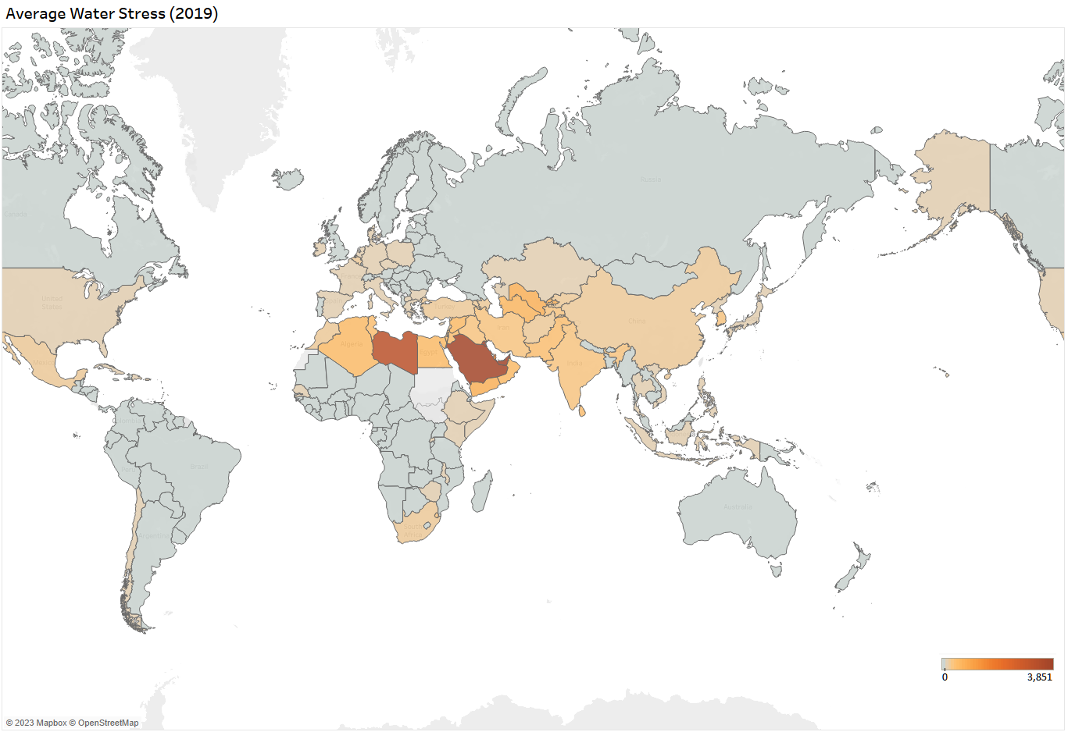

If a country only experiences water stress for a few years, it may be able to rely on non-renewable water sources until the situation eases. “Renewable water resources are not replenished at all of for a very long time by nature. This includes the so-called fossil waters” (European Environment Agency. 2023). Fossil waters are “underground reservoirs formed during the last glacial ice age that may taken thousands of years to be replenished” (TreeHugger, 2022). However, overtime, these countries would most likely experience water scarcity that could lead to impacts on the economy, the environment, and the social cohesiveness of that country. As expected, desertic countries are most affected by water stress. Some of these countries, like the Middle East’s oil-producing ones, turn to alternative techniques such as desalination to compensate their lack of access to water despite these having high environmental costs.

The second question I wanted to explore was which countries experience some level of water dependency that could lead to inter-country conflicts. This measure indicates the proportion of the renewable water available in the country today that originates in another country. The map below does not line up neatly with what we would expect and what we saw with water stress ratios. Here, countries that we don’t think as having water issues show as potentially worrisome. While there is no international standard for this measure to delineate safe and unsafe levels of water dependency, I chose 25% as the center measure. While a country-by-country analysis to assess the real risk would be needed, this is a starting point for future research candidates.

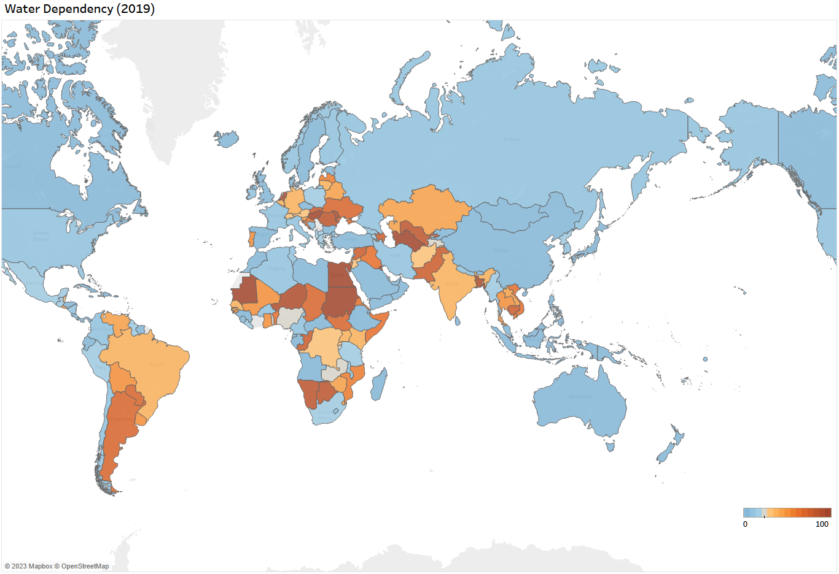

For instance, the Nile, the most famous river in Africa thanks to the pharaohs and their pyramids, takes its source in Lake Victoria in Kenya (White Nile) and Lake Tana in Ethiopia (Blue Nile). It then flows through Uganda, South Sudan, and Sudan before reaching the Mediterranean Sea in Egypt. This makes each country down-river dependent on the neighbor up-river. As water levels decrease, the potential for conflicts between neighbors increase. For instance, Ethiopia has been building a dam on the Blue Nile that the University of South California estimates could reduce water supplies to Egypt by over a third. That studies’ researcher, in turn, predicts a reduction in arable land area in that country by up to 72% with an impact of $51 billion on the agriculture sector, leading to a jump in unemployment to 24%. These sizable shifts would have great consequences for Egypt and tension has risen between both countries (Polakovic, 2021).

There were many countries on this map that surprised me, but none less that seeing the Netherlands as being water dependent. I have always heard of the Netherlands great dam works to keep the North Sea at bay and of Amsterdam’s centuries-old canals. And yet, 87% of that country’s water originates overseas via its three main rivers. The Rhine begins in Switzerland and acts as the border between that country and Lichtenstein before doing the same for Germany and France, finally reaching Spijk in the Groningen province. In turn, the Meuse takes its source in France and flows through Belgium before crossing the Dutch border. Finally, the Eems originates in Western Germany. This renders most of the Netherlands’ water supply dependent on five countries. While there doesn’t seem to be an immediate risk here as we saw earlier between Egypt and Ethiopia, the consequences of climate change may complicate inter-country cooperation if water in these rivers became more and more scarce as is predicted.

Water stress and water dependencies are just two of the measures we covered here. These two measures are just a starting point on what water-related issues a country could face. The graph below shows the earth surface temperatures from 1961 until 2021. While this is probably not a surprise to most people, the inexorable upward trajectory of that line and the constant increase in world population do not invoke optimism as to the continued impact of climate change on our access to water.

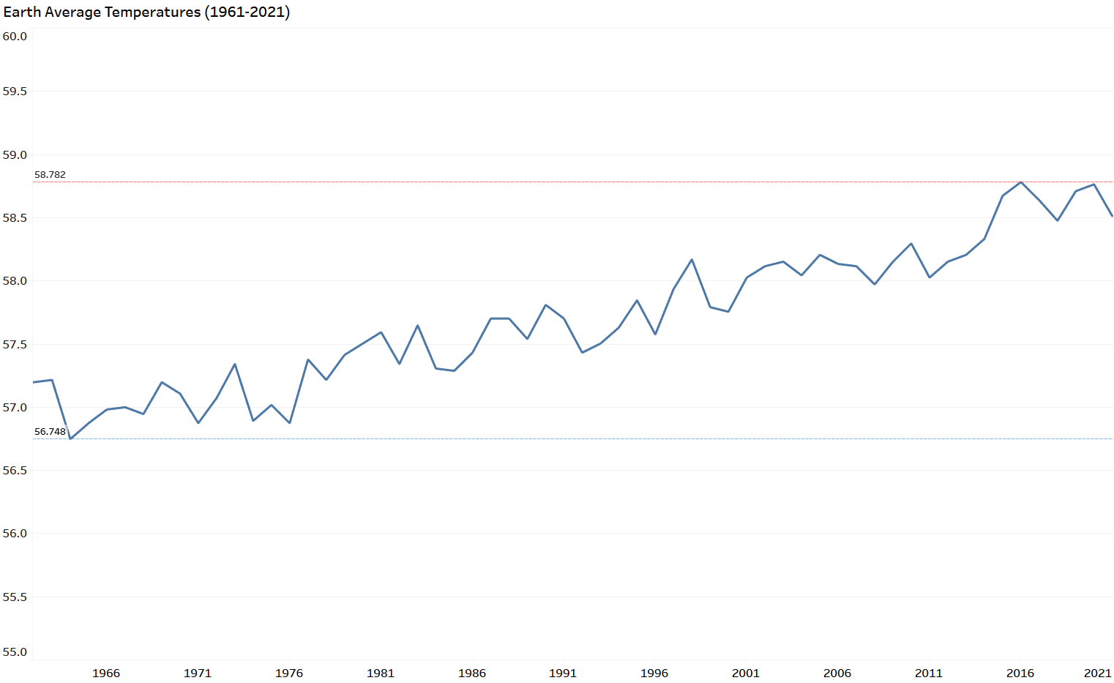

As water-related data is tracked in more details and more years become available, it will be interesting to see if the findings in this report need to be adjusted. Ten years is probably too short a time frame to reach any definitive conclusion. Also, while this is a good place to start, many factors that were beyond the scope of this paper also impact the ability of a country to deal with water stress. Similarly, two countries showing a high percentage of water dependency will not have the same level of risk based on the relationship with the neighbors they depend on. To research the impact of water availability on a country further, a possible future research question may be “what are the other water-related variables influencing a country’s population’s health outcomes or economic well-being?”

# References

World Resources Institute. (2023). *17 Countries, Home to One-Quarter of the World's Population, Face Extremely High Water Stress.* <https://www.wri.org/insights/17-countries-home-one-quarter-worlds-population-face-extremely-high-water-stress>

European Environment Agency. (2023). W*ater resources definition*.

<https://www.eea.europa.eu/help/glossary/eea-glossary/water-resources>

TreeHugger. (2022, October 25). *What Is Fossil Water? Geology and Renewability*.

<https://www.treehugger.com/what-is-fossil-water-6361463>

Gary Polakovic. (2021, July 13)*. Water dispute on the Nile River could destabilize the region.*

<https://news.usc.edu/188414/nile-river-water-dispute-filling-dam-egypt-ethiopia-usc-study>

# Data Sources

The World Bank: <https://databank.worldbank.org/reports.aspx?source=2>

and <https://datacatalog.worldbank.org/search/dataset/0040276>

United Nations – Department of Economic and Social Affairs – Statistics Division:

<https://unstats.un.org/unsd/methodology/m49/overview/>

Food and Agriculture Organization of the United Nations (Aquastat):

<https://tableau.apps.fao.org/views/AQUASTATDashboard/country_dashboard?%3Aembed=y&%3AisGuestRedirectFromVizportal=y>

NOAA National Centers for Environmental information, Climate at a Glance: Global Time Series:

<https://www.ncei.noaa.gov/access/monitoring/climate-at-a-glance/global/time-series>